Studebaker Car Club of Australia Inc.

Annual Display Day

Yea, Victoria

‘Yea Recreation Reserve & Showgrounds’

Saturday October 26th, 2024

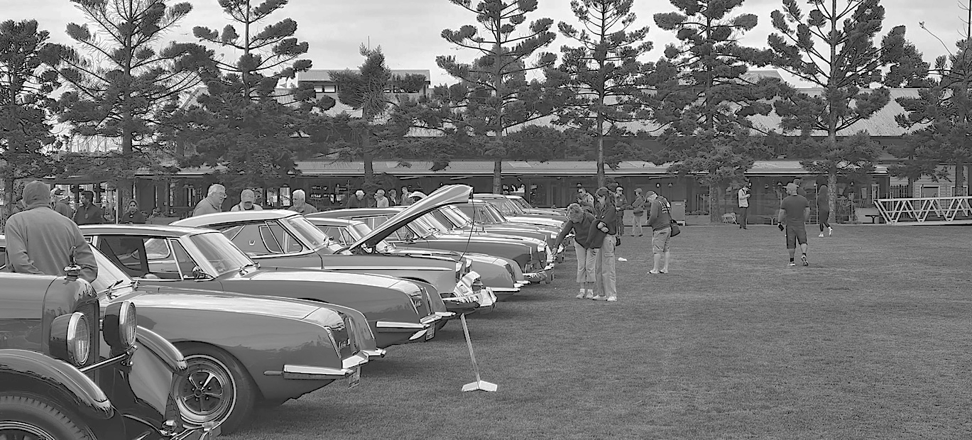

\*\*Free entry to everyone\*\*

Time: 10:00am – 4:00pm

Address: 20 Snodgrass Street, Yea, VIC, 3717

The Studebaker Car Club of Australia Inc. will be celebrating its annual vehicle display day at the Yea Recreation Reserve & Showgrounds on Saturday, October 26th, 2024. Please come and enjoy our member’s hospitality and to see a unique assortment of classic American cars, trucks, and more! We are excited to meet the wonderful Yea community and encourage all ages to attend.

See you in Yea on October 26th!

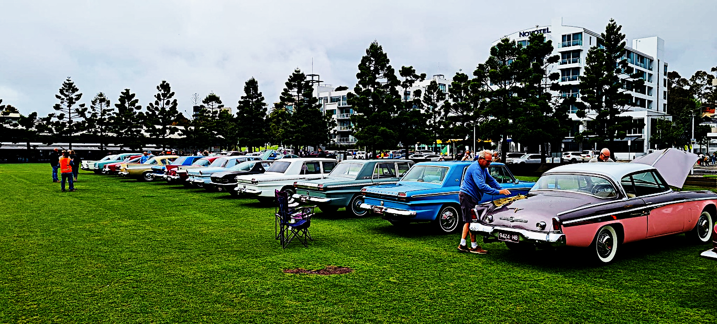

*We would like to extend a special thank-you to the Yea Cricket Club and Recreation Reserve Committee for their generosity and assistance in organising this event.*